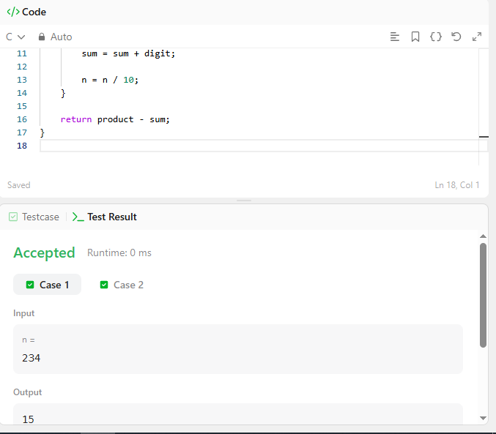

CODE –

int subtractProductAndSum(int n) {
int product = 1;
int sum = 0;
int digit;

while (n > 0) {
digit = n % 10;

product = product * digit;
sum = sum + digit;

n = n / 10;
}

return product - sum;
}

LINK –
https://leetcode.com/problems/subtract-the-product-and-sum-of-digits-of-an-integer/

